Parameters | AR | L (m) | φ (%) | $$Q_{w}\left(m^{3}/s\right)$$ | $$Q_{a}\left(m^{3}/s\right)$$ | h (m) | $V_{a}$ (m/s) | R (m) | σ
Training
Mean | 1.095 | 3.221 | 28.859 | 11.932 | 13.574 | 3.797 | 8.545 | 0.008 | 7.956
St deviation | 0.444 | 1.920 | 16.808 | 7.542 | 12.991 | 2.656 | 8.159 | 0.003 | 16.923
Variance | 0.197 | 3.685 | 282.525 | 56.883 | 168.762 | 7.055 | 66.568 | 0.000 | 286.373
Kurtosis | -1.533 | -1.411 | -0.719 | -0.048 | 0.200 | -1.466 | 0.206 | -0.719 | 9.138
Skewness | 0.267 | 0.305 | 0.699 | 0.813 | 1.018 | 0.343 | 1.021 | 0.289 | 2.916
Range | 1.067 | 5.000 | 50.000 | 31.700 | 57.526 | 7.449 | 36.170 | 0.011 | 91.509
Minimum | 0.600 | 1.000 | 10.000 | 1.600 | 0.000 | 0.540 | 0.000 | 0.003 | -4.677
Maximum | 1.667 | 6.000 | 60.000 | 33.300 | 57.526 | 7.989 | 36.170 | 0.014 | 86.832
Sum | 441.400 | 1298.000 | 11630.000 | 4808.450 | 5470.424 | 1530.175 | 3443.530 | 3.102 | 3206.430
Count | 403.000 | 403.000 | 403.000 | 403.000 | 403.000 | 403.000 | 403.000 | 403.000 | 403.000
Testing
Mean | 1.063 | 3.366 | 30.396 | 13.137 | 13.683 | 3.986 | 8.606 | 0.008 | 8.902
Standard deviation | 0.429 | 1.938 | 17.545 | 8.579 | 13.483 | 2.787 | 8.475 | 0.003 | 18.629
Variance | 0.184 | 3.754 | 307.842 | 73.598 | 181.778 | 7.767 | 71.821 | 0.000 | 347.024
Kurtosis | -1.341 | -1.470 | -0.969 | -0.638 | 0.708 | -1.540 | 0.710 | -0.954 | 7.049
Skewness | 0.408 | 0.170 | 0.620 | 0.565 | 1.086 | 0.351 | 1.087 | 0.087 | 2.623
Range | 1.067 | 5.000 | 50.000 | 31.700 | 58.925 | 7.449 | 37.050 | 0.011 | 90.443
Minimum | 0.600 | 1.000 | 10.000 | 1.600 | 0.000 | 0.540 | 0.000 | 0.003 | -3.611
Maximum | 1.667 | 6.000 | 60.000 | 33.300 | 58.925 | 7.989 | 37.050 | 0.014 | 86.832
Sum | 107.400 | 340.000 | 3070.000 | 1326.800 | 1381.972 | 402.573 | 869.190 | 0.808 | 899.141
Count | 101.000 | 101.000 | 101.000 | 101.000 | 101.000 | 101.000 | 101.000 | 101.000 | 101.000

Parameters | AR | φ | R/L | $$F_{r}$$ | $$Q_{a}/Q_{w}$$ | σ
Training
Mean | 1.095 | 28.859 | 0.004 | 25.457 | 1.168 | 7.956
Standard deviation | 0.444 | 16.808 | 0.003 | 19.298 | 1.074 | 16.923
Variance | 0.197 | 282.525 | 0.000 | 372.425 | 1.152 | 286.373
Kurtosis | -1.533 | -0.719 | 1.387 | 0.713 | 0.563 | 9.138
Skewness | 0.267 | 0.699 | 1.380 | 1.140 | 1.133 | 2.916
Range | 1.067 | 50.000 | 0.013 | 81.852 | 4.653 | 91.509
Minimum | 0.600 | 10.000 | 0.000 | 2.031 | 0.000 | -4.677
Maximum | 1.667 | 60.000 | 0.014 | 83.883 | 4.653 | 86.832
Sum | 441.400 | 11630.000 | 1.503 | 10258.974 | 470.620 | 3206.430
Count | 403.000 | 403.000 | 403.000 | 403.000 | 403.000 | 403.000
Testing
Mean | 1.063 | 30.396 | 0.004 | 24.547 | 1.067 | 8.902
Standard deviation | 0.429 | 17.545 | 0.003 | 18.840 | 1.047 | 18.629
Variance | 0.184 | 307.842 | 0.000 | 354.959 | 1.097 | 347.024
Kurtosis | -1.341 | -0.969 | 1.344 | 1.443 | 1.000 | 7.049
Skewness | 0.408 | 0.620 | 1.499 | 1.338 | 1.179 | 2.623
Range | 1.067 | 50.000 | 0.013 | 81.852 | 4.714 | 90.443
Minimum | 0.600 | 10.000 | 0.000 | 2.031 | 0.000 | -3.611
Maximum | 1.667 | 60.000 | 0.014 | 83.883 | 4.714 | 86.832
Sum | 107.400 | 3070.000 | 0.370 | 2479.210 | 107.732 | 899.141
Count | 101.000 | 101.000 | 101.000 | 101.000 | 101.000 | 101.000

ML Models | Optimal Values
Dimensional
GBM | n_estimators = 470, max_depth = 6, learning_rate = 0.051, subsample = 0.940, min_samples_split = 10, min_samples_leaf = 1, and max_features = None
XGB | n_estimators = 474, max_depth = 9, learning_rate = 0.298, subsample = 0.962, colsample_bytree = 0.716, gamma = 0.480, reg_alpha = 0.022, and reg_lambda = 0.083.
CATB | iterations = 475, depth = 8, learning_rate = 0.12760508328206074, l2_leaf_reg = 6.147645152771797, bagging_temperature = 0.9768427864973606, and random_strength = 0.028282687916864738.
XRT | n_estimators = 500, max_depth = 15, min_samples_split = 3, min_samples_leaf = 1, and max_features = None.
RF | n_estimators = 475, max_depth = 12, min_samples_split = 2, min_samples_leaf = 1, and max_features = None.
Non-Dimensional
GBM | n_estimators = 465, max_depth = 6, learning_rate = 0.11441069333248899, subsample = 0.9698690613239506, min_samples_split = 17, min_samples_leaf = 6, and max_features = None.
XBG | n_estimators = 385, max_depth = 4, learning_rate = 0.24391279082974093, subsample = 0.5918556835987723, colsample_bytree = 0.8427619844455038, gamma = 0.0969936996408106, reg_alpha = 0.6473301773166262, and reg_lambda = 0.6151572928889338.
CATB | iterations = 295, depth = 5, learning_rate = 0.2153257951221818, l2_leaf_reg = 1.4311480526560383, bagging_temperature = 0.38040268431334634, and random_strength = 0.7566611066941972.
XRT | n_estimators = 337, max_depth = 16, min_samples_split = 2, min_samples_leaf = 1, and max_features = None.
RF | n_estimators = 167, max_depth = 20, min_samples_split = 2, min_samples_leaf = 1, and max_features = None.

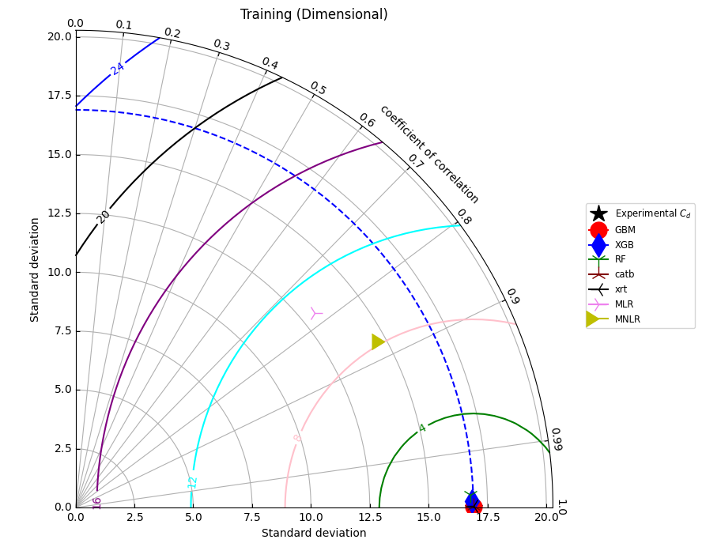
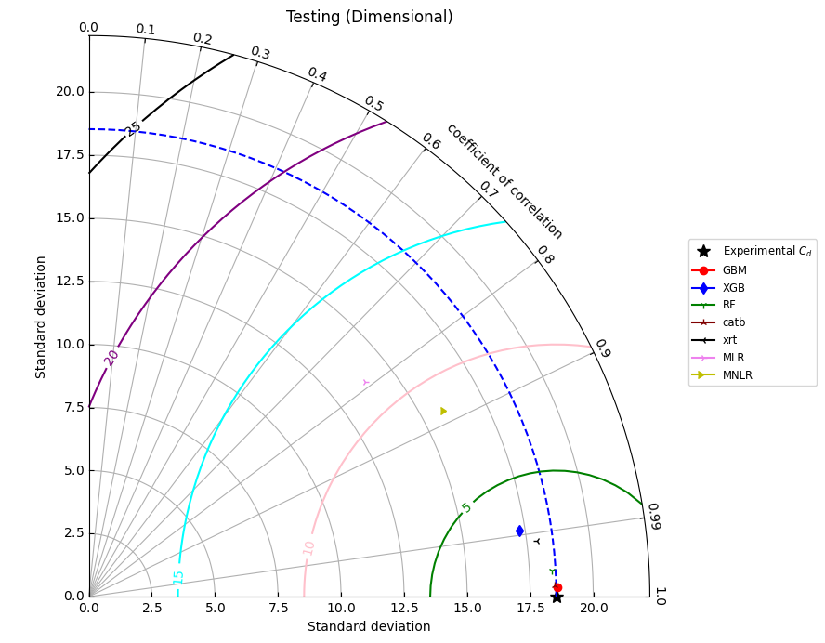

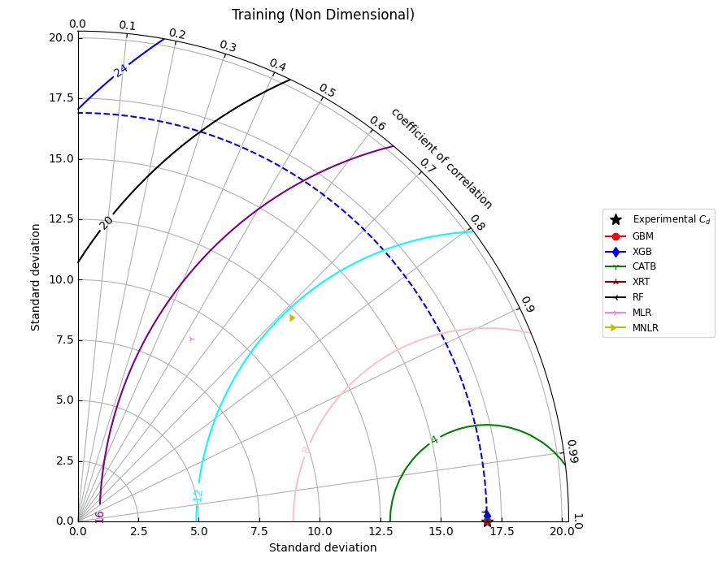
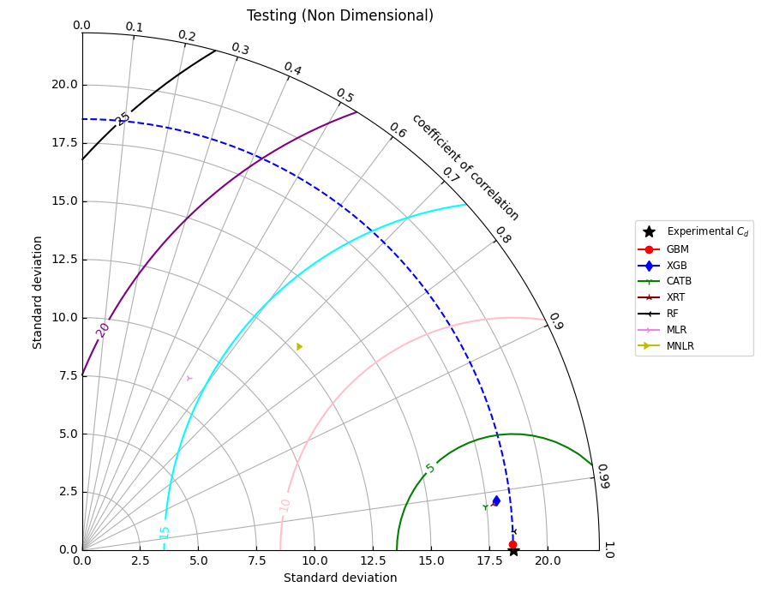

 |  | Training |  |  |  | Testing
S. No. | Model | CC | RMSE | MAE |  | CC | RMSE | MAE
1 | GBM | 1.0000 | 0.0237 | 0.0191 |  | 0.9998 | 0.3632 | 0.2645
2 | XGB | 0.9999 | 0.2708 | 0.1927 |  | 0.9883 | 3.0582 | 0.9845
3 | CATB | 1.0000 | 0.0630 | 0.0499 |  | 0.9984 | 1.0440 | 0.6253
4 | XRT | 1.0000 | 0.0612 | 0.0368 |  | 0.9997 | 0.4645 | 0.3396
5 | RF | 0.9995 | 0.5512 | 0.2918 |  | 0.9922 | 2.3566 | 0.6922
6 | MLR | 0.7747 | 10.6866 | 7.8934 |  | 0.7902 | 11.5881 | 8.5894
7 | MNLR | 0.8811 | 7.9938 | 5.9824 |  | 0.8869 | 8.6708 | 6.5976

 |  | Training |  |  |  | Testing
S. No. | Model | CC | RMSE | MAE |  | CC | RMSE | MAE
1 | GBM | 1.0000 | 0.0284 | 0.0203 |  | 0.9999 | 0.2536 | 0.1883
2 | XGB | 0.9999 | 0.2341 | 0.1790 |  | 0.9929 | 2.2629 | 0.9950
3 | CATB | 1.0000 | 0.1077 | 0.0858 |  | 0.9940 | 2.2702 | 0.7305
4 | XRT | 1.0000 | 0.0010 | 0.0005 |  | 0.9936 | 2.1851 | 0.5207
5 | RF | 0.9997 | 0.4201 | 0.2438 |  | 0.9991 | 0.8091 | 0.5576
6 | MLR | 0.5269 | 14.3647 | 9.5120 |  | 0.5262 | 15.8059 | 10.5582
7 | MNLR | 0.7280 | 11.5876 | 7.6576 |  | 0.7329 | 12.6522 | 8.4276

Combination | Parameter Removed | Train CC | Train RMSE | Test CC | Test RMSE
$σ=f\left(AR,L,ϕ,Q_{w}​,Q_{a}​,h,V_{a}​,R\right)$ | — | 0.999999 | 0.000426 | 0.999782 | 0.151671
$σ=f\left(L,ϕ,Q_{w}​,Q_{a}​,h,V_{a}​,R\right)$ | $$AR$$ | 0.999999 | 0.000583 | 0.999807 | 0.133994
$σ=f\left(AR,ϕ,Q_{w}​,Q_{a}​,h,V_{a}​,R\right)$ | $$L$$ | 0.999999 | 0.000649 | 0.999785 | 0.149208
$σ=f\left(AR,L,Q_{w}​,Q_{a}​,h,V_{a}​,R\right)$ | $$ϕ$$ | 0.999999 | 0.000546 | 0.999808 | 0.132739
$σ=f\left(AR,L,ϕ,Q_{a}​,h,V_{a}​,R\right)$ | $$Q_{w}​$$ | 0.946054 | 29.989704 | 0.914857 | 56.046437
$σ=f\left(AR,L,ϕ,Q_{w}​,h,V_{a}​,R\right)$ | $$Q_{a}​$$ | 0.999999 | 0.000441 | 0.999837 | 0.113311
$σ=f\left(AR,L,ϕ,Q_{w},Q_{a}​,V_{a}​,R\right)$ | $$h$$ | 0.999999 | 0.000790 | 0.999337 | 0.468093
$σ=f\left(AR,L,ϕ,Q_{w},Q_{a}​,h,R\right)$ | $$V_{a}$$ | 0.999999 | 0.000735 | 0.999177 | 0.571065
$σ=f\left(AR,L,ϕ,Q_{w}​,Q_{a}​,h,V_{a}​\right)$ | $$R$$ | 0.999999 | 0.000666 | 0.999775 | 0.154887

Combination | Parameter Removed | Train CC | Train RMSE | Test CC | Test RMSE
$σ=f\left(AR,ϕ,R/L,F_{r},Q_{a}​/Q_{w}​\right)$ | — | 0.999998 | 0.000953 | 0.999826 | 0.119661
$σ=f\left(ϕ,R/L,F_{r},Q_{a}​/Q_{w}​\right)$ | $$AR$$ | 0.999992 | 0.004538 | 0.999571 | 0.295044
$σ=f\left(AR,R/L,F_{r},Q_{a}​/Q_{w}​\right)$ | $$ϕ$$ | 0.999944 | 0.032125 | 0.994813 | 3.752492
$σ=f\left(AR,ϕ,F_{r},Q_{a}​/Q_{w}​\right)$ | $$R/L$$ | 0.999997 | 0.001939 | 0.99988 | 0.082639
$σ=f\left(AR,ϕ,R/L,Q_{a}​/Q_{w}​\right)$ | $$F_{r}$$ | 0.945853 | 30.097985 | 0.867971 | 85.062258
$σ=f(AR,ϕ,R/L,F_{r})$ | $$Q_{a}​/Q_{w}​$$ | 0.999989 | 0.006267 | 0.999734 | 0.190192

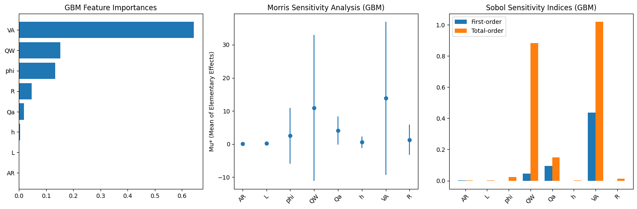

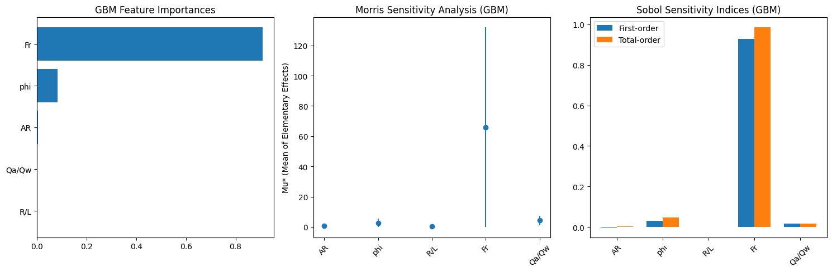
Training (Dimensional)
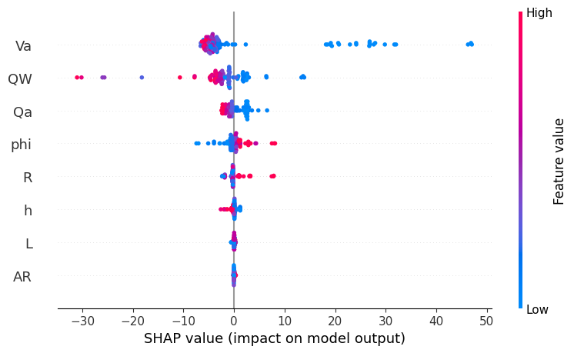
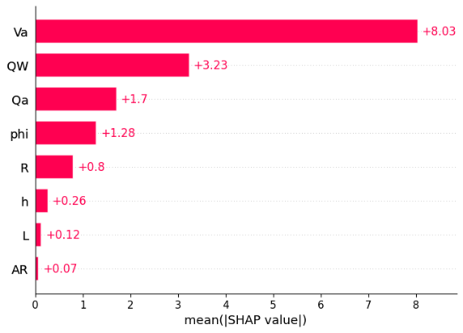

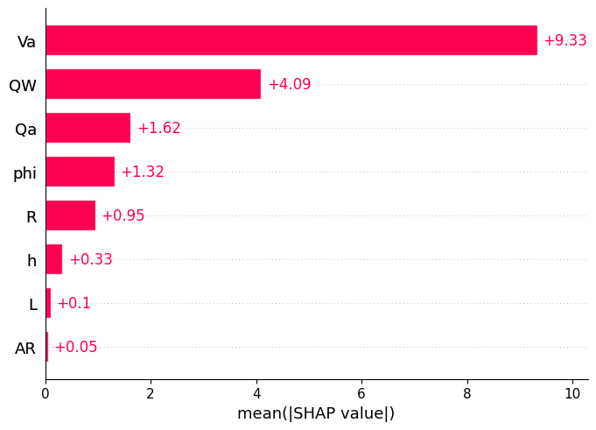
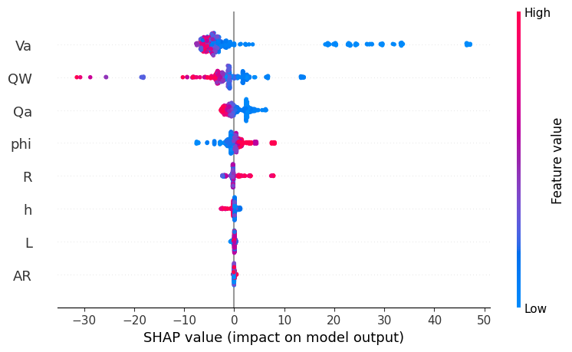
Testing(Dimensional)
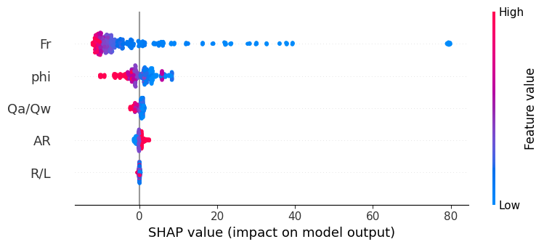
Training (Non-dimensinal)
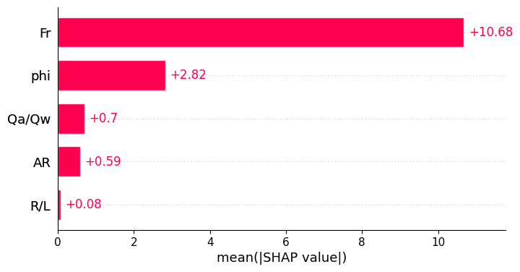
Testing(Non-dimensional)
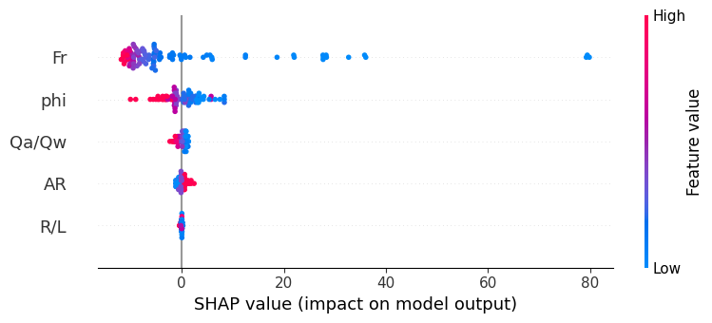
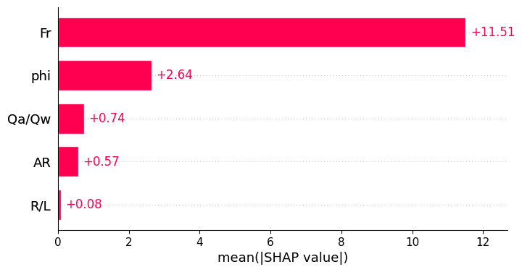

$$x$$

